
  Open Shortest Path First (OSPF) v3 Multiarea Lab  9/11/2025 | Gio Hua  Period 0-2 CCNP

Purpose:
Configure Open Shortest Path First (OSPF) version three across five routers and two multi-layer switches (MLS). Set three routers in area zero as the backbone and connect a router and switch on both sides as area one and two. The multi-layer switches should be configured with routing capabilities.

Background:
Open Shortest Path First (OSPF) is a routing protocol for Internet Protocol (IP) networks. It enlists a link state routing (LSR) algorithm and counts as an interior gateway protocol (IGP). Additionally, it operates within a single autonomous system (AS). OSPF gathers link state info from other routers and constructs a topology map of the network. The topology is shown as a routing table to the internet layer for routing packets by their destination IP address. Furthermore, OSPF supports Internet Protocol version four (IPV4) and Internet Protocol version six (IPV6). Originally developed in the 1980s, OSPF version two was introduced in 1998, while version three was introduced in 2008.
OSPF detects changes in the topology, such as link failures, and converges on a new loop-free routing structure within seconds. It calculates the shortest-path tree (essentially the shortest distance) for each route using a method based on Dijkstra's algorithm (finds the shortest path from a given source node to every other node). Cost of each path may differ due to factors such as distance of the router, data throughput of a link, or link availability and reliability.
OSPF divides the network topology into different areas, delegating resources and traffic to specific areas while simplifying administration. Areas are defined by 32-bit numbers. By default, area zero (0.0.0.0) represents the core or backbone area of the network. Additional areas can be added but must be connected to the OSPF backbone area. These connections are maintained by an interconnecting router, known as the area border router (ABR). The ABR keeps track of the areas it serves and utilizes this information to make a link-state database. OSPF over IPv4 can operate securely between routers, optionally using a variety of authentication methods to allow only trusted routers to participate in routing. OSPFv3 (IPv6) relies on standard IPv6 protocol security (IPsec) and has no internal authentication methods.
OSPFv3 brings modifications to the IPv4 implementation of the protocol. Except for virtual links, all neighbor exchanges use IPv6 link-local addressing exclusively. The IPv6 protocol runs per link, rather than based on the subnet. All IP prefix information has been removed from the link-state advertisements and from the hello discovery packet making OSPFv3 essentially protocol-independent. Despite the expanded IP addressing to 128 bits in IPv6, area and router identifications are still based on 32-bit numbers.
OSPF supports complex networks with multiple routers, including backup routers, to balance traffic load on multiple links to other subnets. Neighboring routers in the same broadcast domain or at each end of a point-to-point link communicate with each other via the OSPF protocol. Routers form adjacencies when they have detected each other. This detection is initiated when a router identifies itself in a hello protocol packet. Upon acknowledgment, this establishes a two-way state and the most basic relationship. The routers in an Ethernet or Frame Relay network select a designated router (DR) and a backup designated router (BDR) which act as a hub to reduce traffic between routers. OSPF uses both unicast and multicast transmission modes to send "hello" packets and link-state updates.

Lab Summary:
Configured OSPFv3 onto five routers and two multi-layer switches (MLS) through a series of commands. IPv4 and IPv6 configurations were necessary across all devices, along with the OSPF processes. MLS configurations were different though; before you can input routes into the switch, you must set them for routing capabilities (using the IP route and IPv6 unicast-routing commands). To ensure the configurations worked, use commands such as show ip ospf neighbor, show ip route ospf, show ip ospf database, and traceroute.

Lab Commands:

Routers (Example is Router two, configure each router with their respective IPs/Areas/Router IDs/Routes):
Configures hostname to “R2”

Allows the router to forward IPv6 data packets between different IP subnets or VLANs
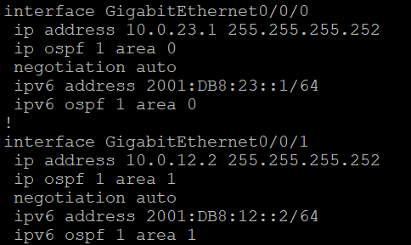
Ip address - Sets the IP address on the interface
Ip ospf 1 area 0 - enables OSPFv2 on the interface and assigns it to OSPF Area 0
Ipv6 address - Sets the IPv6 address on the interface
Ipv6 ospf 1 area 0 - enables OSPFv3 on the interface and assigns it to OSPF Area 0
Negotiation auto - two linked network devices automatically discover and agree on the fastest compatible operating speed and duplex mode to use for their connection

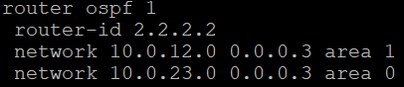
Router ospf 1 - enables the OSPF routing process on the router with the process ID of one
Router-id 2.2.2.2 - Sets the router ID as 2.2.2.2, a unique identifier
Network - activates the OSPF routing protocol on any interfaces with an IP address that falls within the 10.0.12.0 and 10.0.23.0 networks, as defined by the 0.0.0.3 wildcard mask. Additionally, those interfaces and their associated networks are set to OSPF Area 1 and 0 respectively

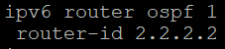
Ipv6 router ospf 1 – enables and initializes the OSPFv3 routing process for the IPv6 network
Router-id 2.2.2.2 - Sets the router ID as 2.2.2.2, a unique identifier

Multi-layer Switches (Example is multi-layer switch two, configure each switch with their respective IPs/Areas/Router IDs/Routes):
Configures hostname to “MLS2”

Enables layer 3 routing capabilities on a multi-layer switch

Allows the switch to forward IPv6 data packets between different IP subnets or VLANs

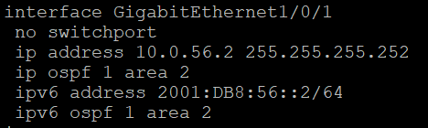
No switchport - converts a Layer 2 switch port into a Layer 3 routed port, allowing it to function like a router interface
Ip address - Sets the IP address on the interface
Ip ospf 1 area 2 - enables OSPFv2 on the interface and assigns it to OSPF Area 2
Ipv6 address - Sets the IPv6 address on the interface
Ipv6 ospf 1 area 2 - enables OSPFv3 on the interface and assigns it to OSPF Area 2

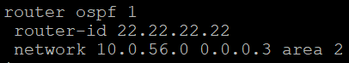
Router ospf 1 - enables the OSPF routing process on the router with the process ID of one
Router-id 22.22.22.22 - Sets the router ID as 22.22.22.22, a unique identifier
Network - activates the OSPF routing protocol on any interfaces with an IP address that falls within the 10.0.56.0 network, as defined by the 0.0.0.3 wildcard mask. Additionally, those interfaces and their associated networks are set to OSPF Area 2

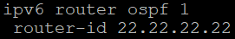
Ipv6 router ospf 1 – enables and initializes the OSPFv3 routing process for the IPv6 network
Router-id 22.22.22.22 - Sets the router ID as 22.22.22.22, a unique identifier

Lab Diagram:
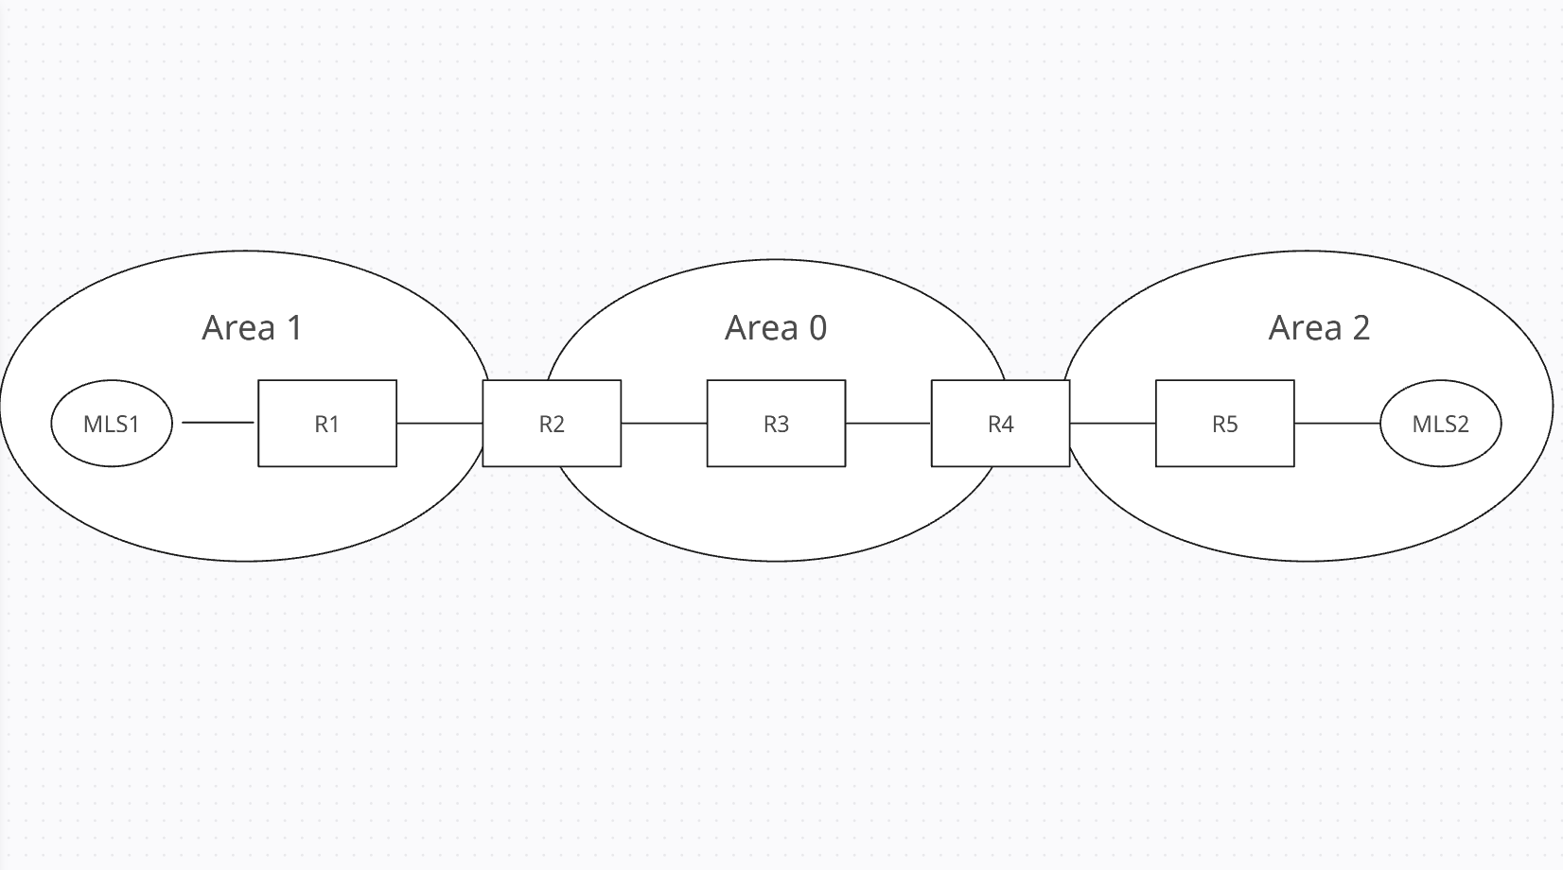

Configurations:
MLS1:
hostname MLS1
ip routing
ipv6 unicast-routing
!
interface GigabitEthernet1/0/1
no switchport
ip address 10.0.11.1 255.255.255.252
ip ospf 1 area 1
ipv6 address 2001:DB8:11::1/64
ipv6 ospf 1 area 1
!
router ospf 1
router-id 11.11.11.11
network 10.0.11.0 0.0.0.3 area 1
!
ipv6 router ospf 1
router-id 11.11.11.11

MLS2:
hostname MLS2
ip routing
ipv6 unicast-routing
!
interface GigabitEthernet1/0/1
no switchport
ip address 10.0.56.2 255.255.255.252
ip ospf 1 area 2
ipv6 address 2001:DB8:56::2/64
ipv6 ospf 1 area 2
!
router ospf 1
router-id 22.22.22.22
network 10.0.56.0 0.0.0.3 area 2
!
ipv6 router ospf 1
router-id 22.22.22.22

R1:
hostname R1
ipv6 unicast-routing
!
interface GigabitEthernet0/0/0
ip address 10.0.12.1 255.255.255.252
ip ospf 1 area 1
negotiation auto
ipv6 address 2001:DB8:12::1/64
ipv6 ospf 1 area 1
!
interface GigabitEthernet0/0/1
ip address 10.0.11.2 255.255.255.252
ip ospf 1 area 1
negotiation auto
ipv6 address 2001:DB8:11::2/64
ipv6 ospf 1 area 1
!
router ospf 1
router-id 1.1.1.1
network 10.0.11.0 0.0.0.3 area 1
network 10.0.12.0 0.0.0.3 area 1
!
ipv6 router ospf 1
router-id 1.1.1.1

R2:
hostname R2
ipv6 unicast-routing
!
interface GigabitEthernet0/0/0
ip address 10.0.23.1 255.255.255.252
ip ospf 1 area 0
negotiation auto
ipv6 address 2001:DB8:23::1/64
ipv6 ospf 1 area 0
!
interface GigabitEthernet0/0/1
ip address 10.0.12.2 255.255.255.252
ip ospf 1 area 1
negotiation auto
ipv6 address 2001:DB8:12::2/64
ipv6 ospf 1 area 1
!
router ospf 1
router-id 2.2.2.2
network 10.0.12.0 0.0.0.3 area 1
network 10.0.23.0 0.0.0.3 area 0
!
ipv6 router ospf 1
router-id 2.2.2.2
R3:
hostname R3
ipv6 unicast-routing
!
interface GigabitEthernet0/0/0
ip address 10.0.34.1 255.255.255.252
ip ospf 1 area 0
negotiation auto
ipv6 address 2001:DB8:34::1/64
ipv6 ospf 1 area 0
!
interface GigabitEthernet0/0/1
ip address 10.0.23.2 255.255.255.252
ip ospf 1 area 0
negotiation auto
ipv6 address 2001:DB8:23::2/64
ipv6 ospf 1 area 0
!
router ospf 1
router-id 3.3.3.3
network 10.0.23.0 0.0.0.3 area 0
network 10.0.34.0 0.0.0.3 area 0
!
ipv6 router ospf 1
router-id 3.3.3.3
R4:
hostname R4
ipv6 unicast-routing
!
interface GigabitEthernet0/0/0
ip address 10.0.45.1 255.255.255.252
ip ospf 1 area 2
negotiation auto
ipv6 address 2001:DB8:45::1/64
ipv6 ospf 1 area 2
!
interface GigabitEthernet0/0/1
ip address 10.0.34.2 255.255.255.252
ip ospf 1 area 0
negotiation auto
ipv6 address 2001:DB8:34::2/64
ipv6 ospf 1 area 0
!
router ospf 1
router-id 4.4.4.4
network 10.0.34.0 0.0.0.3 area 0
network 10.0.45.0 0.0.0.3 area 2
!
ipv6 router ospf 1
router-id 4.4.4.4
R5:
hostname R5
ipv6 unicast-routing
!
interface GigabitEthernet0/0/0
ip address 10.0.56.1 255.255.255.252
ip ospf 1 area 2
negotiation auto
ipv6 address 2001:DB8:56::1/64
ipv6 ospf 1 area 2
!
interface GigabitEthernet0/0/1
ip address 10.0.45.2 255.255.255.252
ip ospf 1 area 2
negotiation auto
ipv6 address 2001:DB8:45::2/64
ipv6 ospf 1 area 2
!
router ospf 1
router-id 5.5.5.5
network 10.0.45.0 0.0.0.3 area 2
network 10.0.56.0 0.0.0.3 area 2
!
ipv6 router ospf 1
router-id 5.5.5.5

Problems: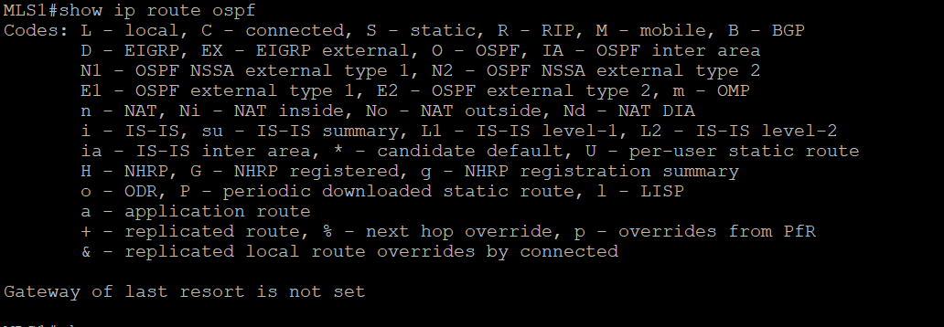
Issue: Routes were not appearing; link was down between MLS1 and R1
Solution: Replace ethernet cable

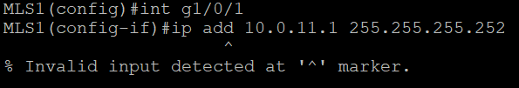
Issue: Could not configure IP address on MLS1
Solution: Since the switch is multi-layer, you must decide between routing capabilities (layer 3) and switch capabilities (layer 2). Use command no switchport on the interface

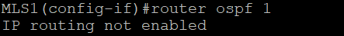
Issue: Could not configure router OSPF command on MLS1
Solution: By default, a multi-layer switch does not have routing capabilities enabled. Use command ip-routing in global configuration

Issue: Area mismatch throughout all routers
Solution: Assigned the corresponding IPs and network addresses to the correct areas and interfaces

Conclusion:
I learned how to set up a multi-area OSPF topology and configure it with commands. Having previously lacked working with multi-layer switches, this lab was an opportunity to experiment with the layer 2 and layer 3 capabilities. Additionally, my ability and confidence to configure an OSPF lab has increased.

